Technical Design for Facial Animation

Revision History

Issue | Date | Person | Reason
0.1 | March 27, 2002 | Darryl Long | Created
1.0 | April 12, 2002 | Darryl Long | Reviewed by team and released

Description

Introduction
The Facial Animation system will provide four types of animation: mouth-flapping, blinking, head tracking and eyeball tracking.

The system uses the Simulation and Choreo libraries for basic animation manipulation. It provides an easy set of methods for setting a character, setting the types of animation, and keeping that character interesting and life-like.

Requirements
- Mouth flapping
- Blinking
- Head-tracking
- Eyeball-tracking
- Works on any character

References
- Talked to Yayoi about what she wants
- Talked to Aryan about skeleton design

Technical Design

Overview
The FacialAnimation class aggregates all the ambient and cyclic animation needed to make a character look alive and non-zombie (as the kids are saying these days). The amount the character moves around is tunable in code.

The character can be told to look at a location, and his eyes and head will turn towards that location. The eyes move faster than the head

It is possible to add extra “ambient” animations. For instance, we might want o have the character’s eyes moving around a little bit while he’s talking. People tend not to stare straight ahead the whole time they are talking.

Relationships
When creating characters or creating scenes something will want to set which characters the facial animation system is operating upon. This may be the Presentation Manager.

The AI component will want to be able to set what the character is looking at.

Whatever system starts the character talking will want to also tell the Facial Animation system to start that character’s mouth flapping.

Interface

class FacialAnimation : public tEntity
{
public:
FacialAnimation( tPose* pose, rmt::Randomizer* randomizer,
tFrameController* blinkController );
~FacialAnimation();

void SetCharacter( tCompositeDrawable* character );
void StartTalking();
void StopTalking();
void SetLookTarget( rmt::Vector target );

void Update( float elapsedTime ); // milliseconds
}

Sadly, because of the way poser is set up, you can’t transfer the facial animation from one tPose to another. SetCharacter won’t really do much until I can figure a way around this. You need to create a new FacialAnimation thingy.

The character will blink automatically every 2.5 to 3.5 seconds. Use StartTalking to begin the mouth-flapping and random head movements, and StopTalking to stop them. Use SetLookTarget to point the characters head and eyes at something.

Update is called every frame to continue the animation.

Component Class Diagrams
The Facial Animation has three classes: the FacialAnimation class, the CyclicAnim class and the TalkAnim class.

The FacialAnimation class is a general access class encapsulating the three parts of facial animation: eyes, mouth, and head. It contains an instance of the CyclicAnim class for the blinking of the eyes, two instances of the TalkAnim class for random head movements while talking and the movement of the jaw.

It also contains three sim::TrackerJointModifier instances for head and eye tracking.

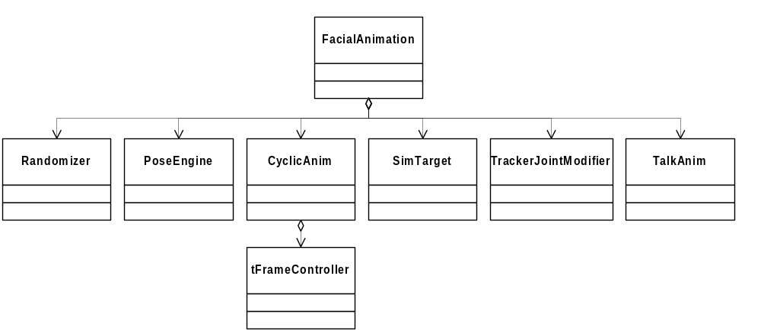

The FacialAnimation class can be easily extended for more ambient animation by adding TalkAnim instances. For instance, if you want the character to wave his hands around while he is talking, add a TalkAnim tied to the shoulder joint and a TalkAnim tied to the elbow joint.

Use Cases

Initialization:

mRandomizer = new rmt::Randomizer( seed );

p3d::load("homer.p3d");

mFigure = p3d::find<tCompositeDrawable>( "Motion_Root" );
rAssert( mFigure );
mFigure->AddRef();

tPose* pose = mFigure->GetPose();
rAssert( pose );

mEyeController = p3d::find<tFrameController>( "TEX_Eyeball_m" );
rAssert( mEyeController );
mEyeController->AddRef();

mFacialAnimation = new FacialAnimation( pose, mRandomizer, mEyeController);
mFacialAnimation->AddRef();

Update every frame:

mFacialAnimation->Update( (float)elapsedTime );

